Errors and Updates
Invalid Actor Error 1
W9 “fakepath” error 1
ACH Form Verification 1
Downloading an ACH Form 2
Name not listed on Account 2
Missing Commodity Code 3

Invalid Actor Error
Any error involving the username with come up as an Actor error. In order to Avoid this error, the prospective vendor should do the following

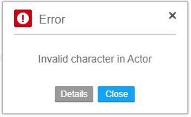

  - Username: Your login username is case sensitive and space sensitive. The Username should not contain any spaces or special characters.

  - Password: Your password minimum password length is 8 (eight) characters with NO REPEAT CHARACTERS. [i.e., Apple]. Do not use your username

W9 “fakepath” error
Upon uploading their w9 the following will appear: "C:\fakepath\\thenameofyourfile" as shown below
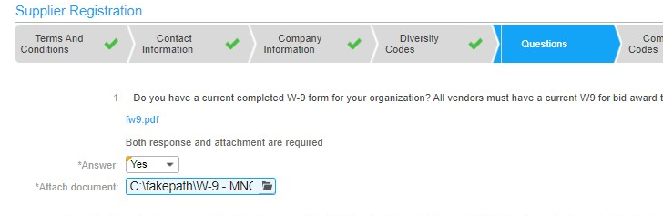
This is NOT an Error but a security measure to protect your information.

ACH Form Verification

Downloading an ACH Form
Vendors should Download the ACH form on the questions tab during registration. They can also retrieve it from the Supplier Portal Homepage at www.mncppc.org/register. The Vendor should complete the form according to the Instructions on page one and return it to ACH@mncppc.org.
- The ACH form should be submitted once you receive and forward their 6 digit Vendor Number.

Name not listed on Account

Accounting Representatives should be listed as secondary contact on the Supplier Portal.
- Sign into the supplier portal
- Once on the home page, go to My Account and select Update Account Information

- Under My Contact Information, select My Contacts

- Select Create Contact

- Create your unique Username and Password
  - Username: Your login username is case sensitive and space sensitive. The username should not contain any spaces or special characters.
  - Password: Your password minimum password length is 8 (eight) characters with
  - NO REPEAT CHARACTERS. [i.e. Apple]. Do not use your username

- Add all contact information for the Accounting Representative including contact information, address and email address.

- Select Save.

Missing Commodity Code

- Sign into the supplier portal
- Once on the home page, go to My Account and select Update Account Information

- Under My Contact Information, select Commodity Codes
- Click the Helper List 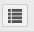, click into the Commodity Search field and type in your service. If no exact commodity is available for your service, choose a similar commodity.
  - To display codes with a description that includes a specific keyword, enter only that word. Example: office.
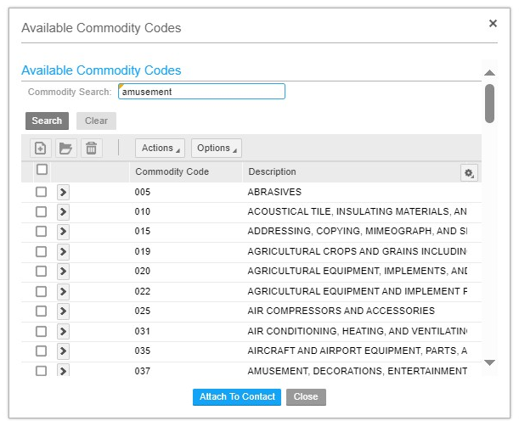

- Find all applicable codes and click Attach To Contact. When all are selected, click Close.

